|  |
| --- |
| Name:H J K I Wijerama |
| Student Reference Number:10707417 |



|  |  |  |
| --- | --- | --- |
| Module Code:SOFT225SL | Module Name: Software Engineering for the internet using Java | |
| Coursework Title:Final report | | |
| Deadline Date:  28 / 04 / 2021 | | Member of staff responsible for coursework:  Mr. Kaneeka Vidanage |
| Programme: BSc(Hons)Software Engineering | | |
| Please note that University Academic Regulations are available under Rules and Regulations on the University website [www.plymouth.ac.uk/studenthandbook](http://www.plymouth.ac.uk/studenthandbook). | | |
| Group work: please list all names of all participants formally associated with this work and state whether the work was undertaken alone or as part of a team. Please note you may be required to identify individual responsibility for component parts.   * 10707417-H.J.K.Isindu Wijerama * 10707129-K.L.Dulani Anupama * 10707216-K.Charuka Heshan * 10713401-U.R.K.Ukwatta * 10707256 - N.N.D.G.Liyanage   ***We confirm that we have read and understood the Plymouth University regulations relating to Assessment Offences and that we are aware of the possible penalties for any breach of these regulations. We confirm that this is the independent work of the group.***  Signed on behalf of the group:  nn  H.J.K.I. Wijerama | | |

|  |
| --- |
| Individual assignment: ***I confirm that I have read and understood the Plymouth University regulations relating to Assessment Offences and that I am aware of the possible penalties for any breach of these regulations. I confirm that this is my own independent work.***  Signed : |
| Use of translation software: failure to declare that translation software or a similar writing aid has been used will be treated as an assessment offence.  I *have used/not used translation software.  If used, please state name of software………………………………………………………………… |
| **Overall mark _____% Assessors Initials ______ Date_________** |



**SOFT225SL – Software Engineering for the**

**Internet using Java**

Group members :

* 10707417-H.J.K.Isindu Wijerama
* 10707129-K.L.Dulani Anupama
* 10707216-K.Charuka Heshan
* 10713401-U.R.K.Ukwatta
* 10707256 - N.N.D.G.Liyanage

**Table of Content**

* Introduction
* Introduction to project
* Problem Statement
* Project Modules
* Technology
* UML Diagrams
* Usecase Diagrams
* Class Diagrams
* Activity Diagrams
* Task Specific Sequance Diagrams
* Screenshots
* Conclusion
* References
* Contribution

**Introduction**

Introduction to project

The Hospital Management System is intended for any emergency clinic to supplant their current manual paper based framework. The undertaking Hospital Management framework incorporates enrollment of patients, putting away their subtleties into the framework, and furthermore automated charging in the drug store, and labs. The motivation behind the undertaking entitled as "Clinic MANAGEMENT SYSTEM" is to mechanize the Front Office Management of Hospital to create programming which is easy to use basic, quick, and cost – compelling. The new framework is to control the data of patients. Room accessibility, staff and working room timetables and patient solicitations. I have planned the given proposed framework in the JSP to computerize the interaction of everyday exercises of Hospital like Room exercises, Admission of New Patient, Discharge of Patient, Assign a Doctor, lastly register the bill and so forth, All the control is under the head and different individuals reserve the privileges to simply see the records not to change any exchange or passage. These administrations are to be given in a productive, practical way, to lessen the time and assets at present needed for such undertakings .

Problem statements

It is vital to keep up productive programming to deal with data of a medical clinic. This application gives an approach to record this data and to get to these in a basic manner

Project Modules

Hospital Details, Department Details, Room Type Details, Room Details, Designation Master, Staff Education, Staff Master, Staff Personal Details, Out Patient, Out Patient Consultancy Charge Entry, Consultancy Report, In Patient Master, Patient Admission, Charges Master, Bill Entry and Print

Technology

Front End : J2EE

Back End : HTML,CSS

**Website Map**

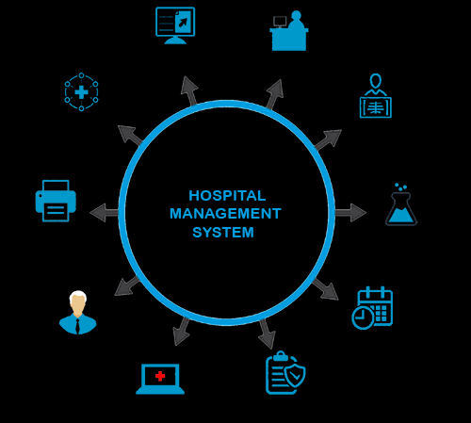

**UML DIAGRAMS**

An outline is the graphical show of a bunch of components, frequently delivered as an associated diagram of vertices and circular segments . you attract chart to imagine a framework from alternate point of view, so a chart is a projection into a framework. For everything except most trifling frameworks, an outline addresses an omitted perspective on the components that make up a framework. A similar component may show up in all outlines, a couple of graphs , or in no charts by any means. In hypothesis, a chart may contain any mix of things and connections. By and by, in any case, few normal mixes emerge, which are predictable with the five most helpful perspectives that contain the engineering of a product concentrated framework. Consequently, the UML incorporates nine such outlines:

Usecase Diagram

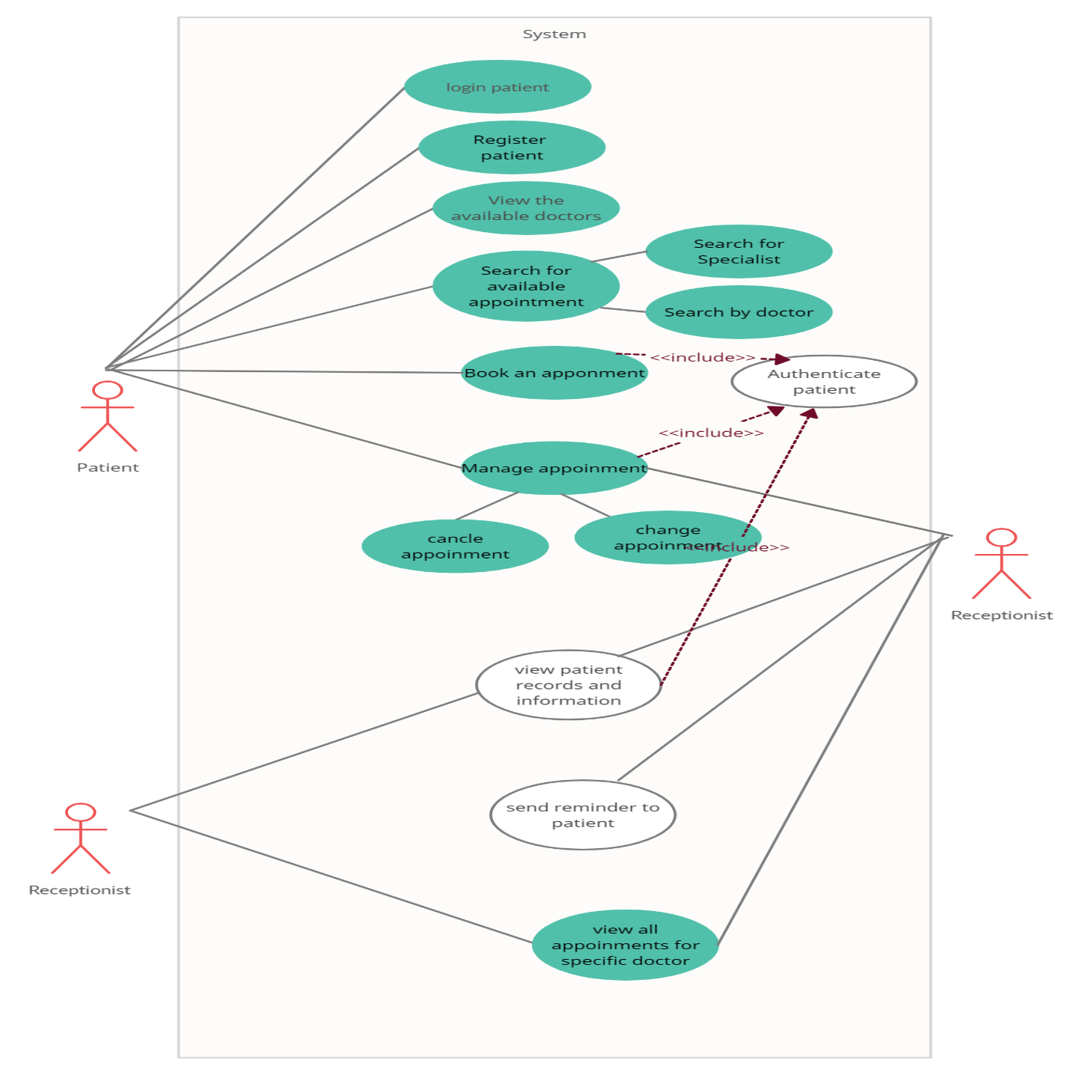

Class Diagram

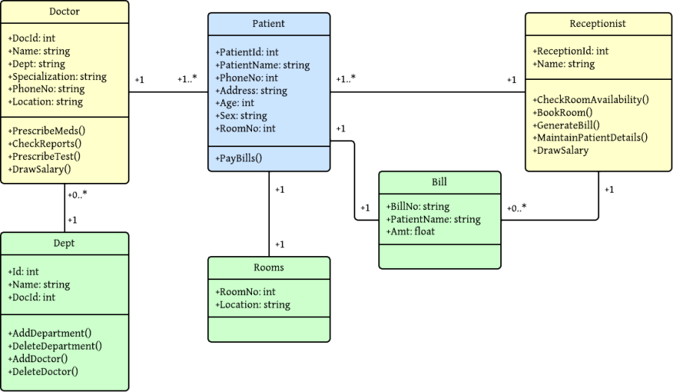

Sequence Diagram

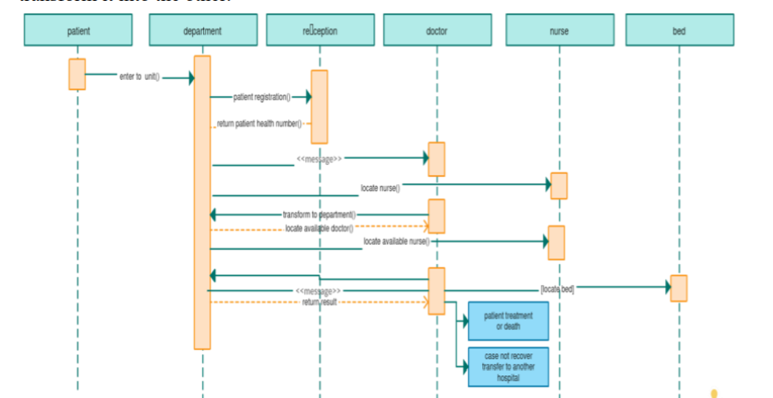

Activity Diagram

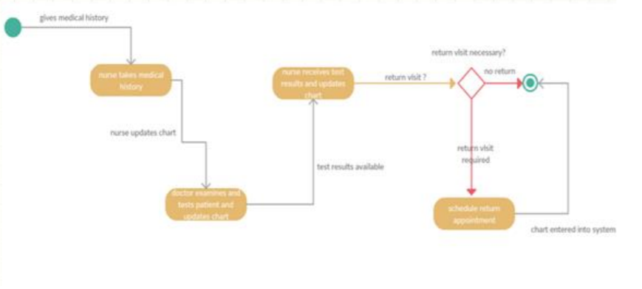

Development Diagram

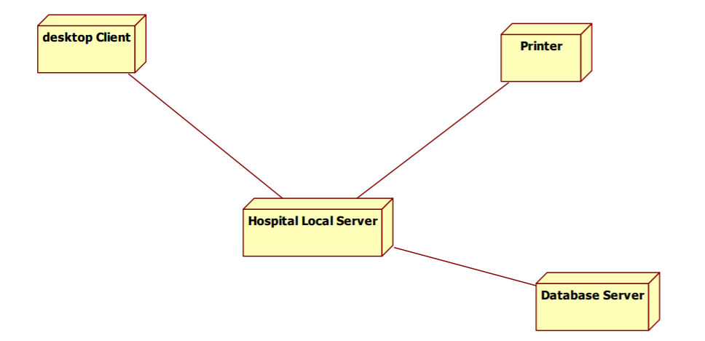

Flow chart

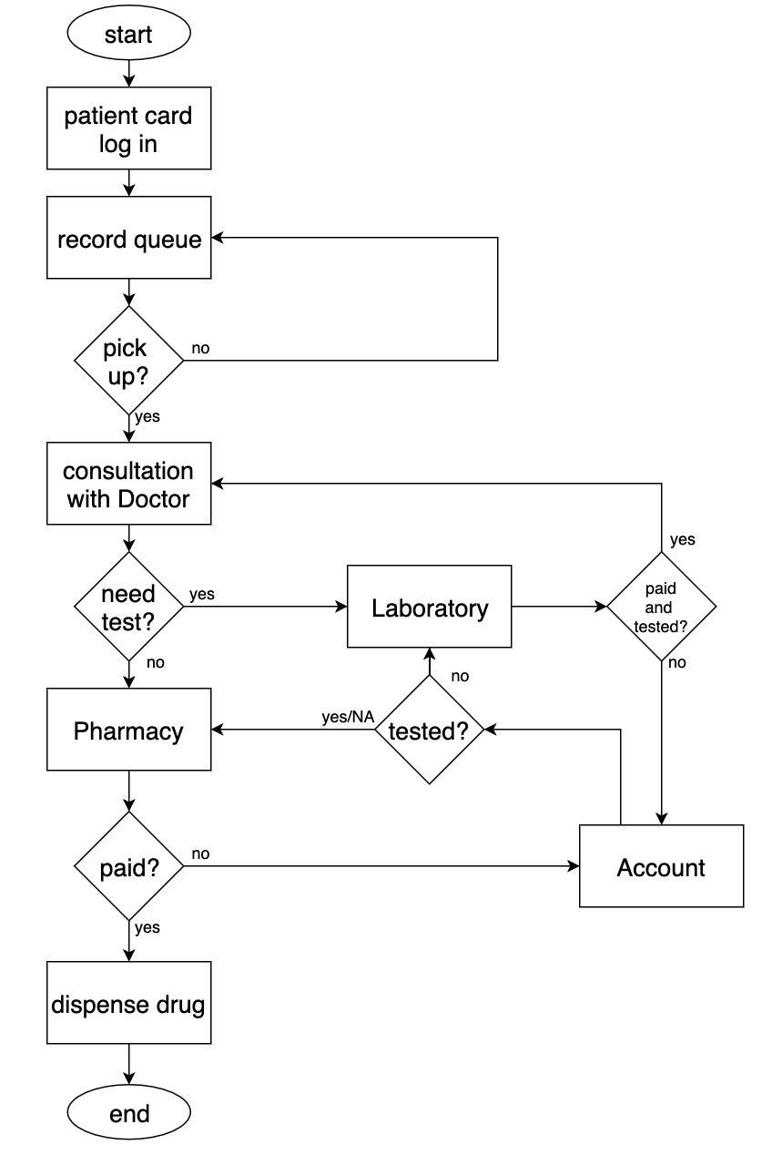

**Home page**

This is our home page of Hospital management system. The Hospital Management System (HMS) is an incorporated programming that handles various bearings of facility work processes. It deals with the smooth medical services execution alongside regulatory, clinical, legitimate and monetary control. That is a foundation for the fruitful activity of the medical services office.

**Login page**

This is login page of our Hospital Management System. simple login page for all users where users need to select their desired category to log in.

**Patient Login Form**

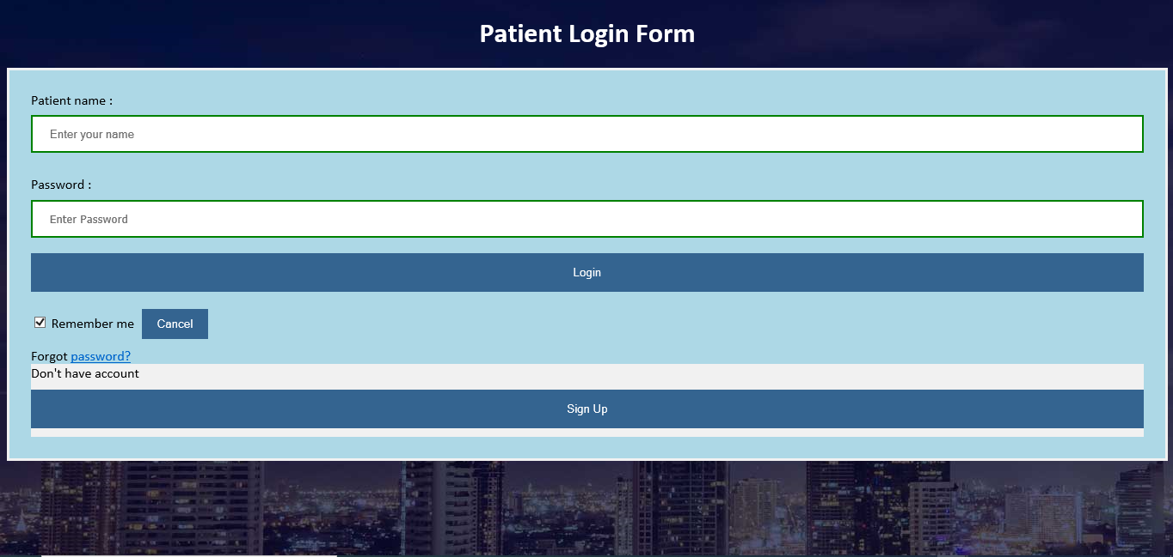

Patient’s login form for our hospital management system all clients where clients need to choose their ideal class to log in. Subsequent to giving the appropriate client name and password you will actually want to

Log in and appreciate every one of those highlights that are intended for you. This is a solitary interface for all gatherings of individuals related with the framework.

**Patient Registration Page**

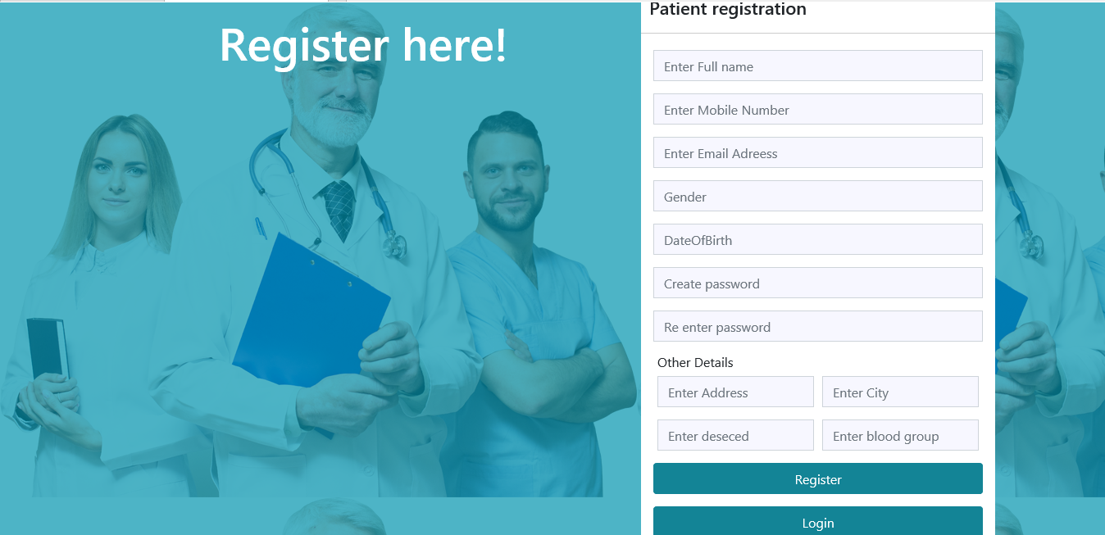

Patient Registration module of our Hospital management system the executives framework is intended to oversee fundamental data for the patient data outline, which denotes the start of socioeconomics catch. It incorporates the patient's full name, Patient’s Mobile number, Email Address, Gender, contact data, birth date, password, other details, and protection data.

Interesting patient ID for following visits Consequently confirms patients' advantages qualification utilizing.

It is utilized to control patient stream. It very well may be utilized to enlist them, get the information of the patients' ailment, see the therapy and check the clinical history and reports.

**Patient Home page**



Patients are ordinary clients like us. We will actually want to peruse accessible specialists and request arrangements. We can likewise check our past history. The patient's usefulness is restricted dependent on their need. They may have the option to change their own data and different things. Clearly they can search for their ideal specialists to demand an arrangement.

**Admin Login page**

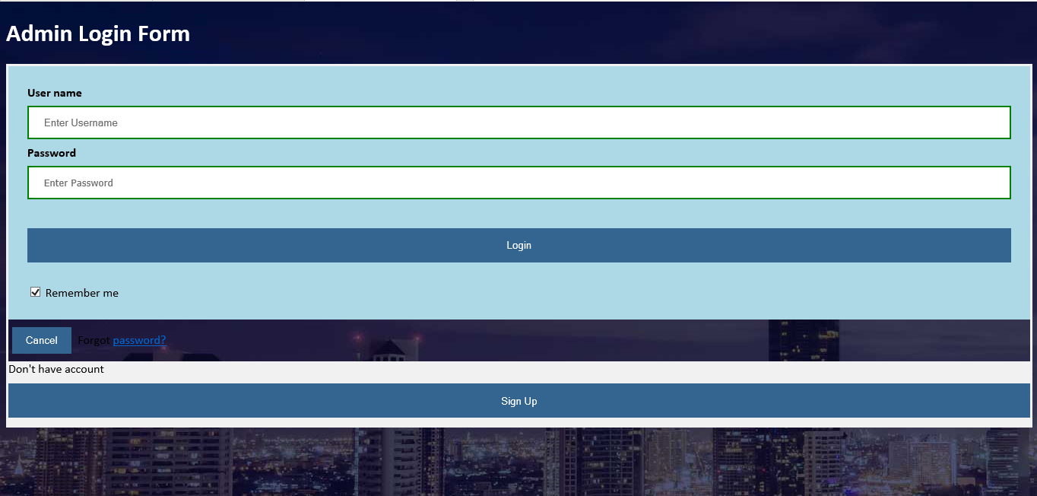

Admin’s login form for our hospital management system all clients where clients need to choose their ideal class to log in. Subsequent to giving the appropriate Admin name and password you will actually want to

Log in and appreciate every one of those highlights that are intended for you. This is a solitary interface for all gatherings of individuals related with the framework.

**Admin Registration Page**

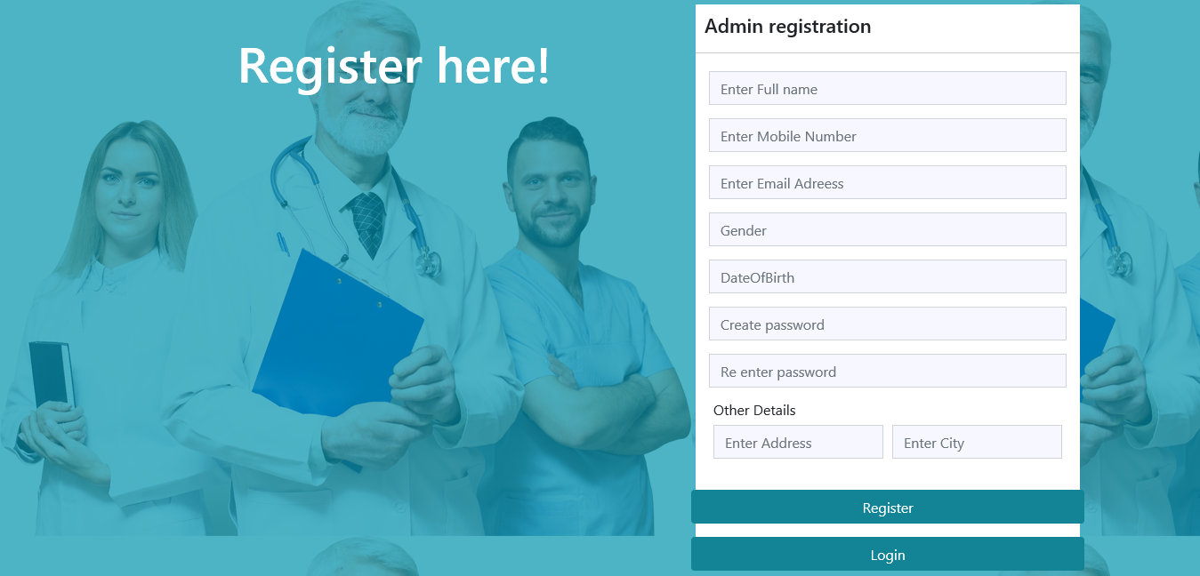

Admin Registration module of our Hospital management system the executives framework is intended to oversee fundamental data for the admin data outline, which denotes the start of socioeconomics catch. It incorporates the admin's full name, admin’s Mobile number, Email Address, Gender, contact data, birth date, password, other details, and protection data.

It is utilized to control admin stream. It very well may be utilized to enlist them, get the information of the admin' ailment, see the therapy and check the clinical history and reports

**Admin Home Page**



The Admin has the ability to make client profile both for patients and specialists. They will be answerable for affirming arrangements and screen through forthcoming test reports. They will have the main activities. As numerous significant things will rely upon their activity.

**Receptionist Login Form**

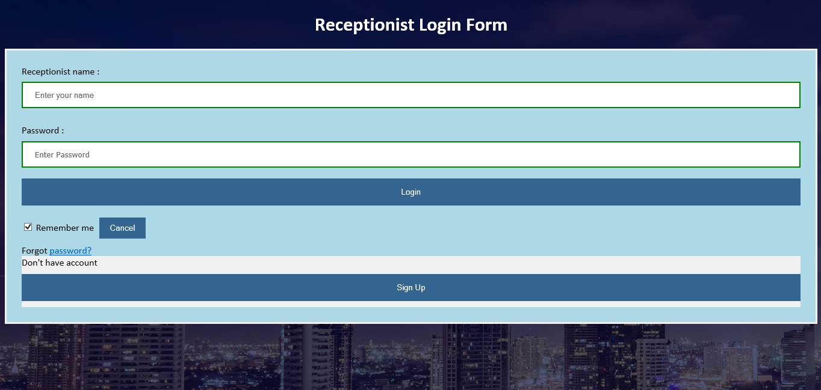

Receptionist’s login form for our hospital management system all clients where clients need to choose their ideal class to log in. Subsequent to giving the appropriate receptionist name and password you will actually want to

Log in and appreciate every one of those highlights that are intended for you. This is a solitary interface for all gatherings of individuals related with the framework.

**Receptionist Registration Page**

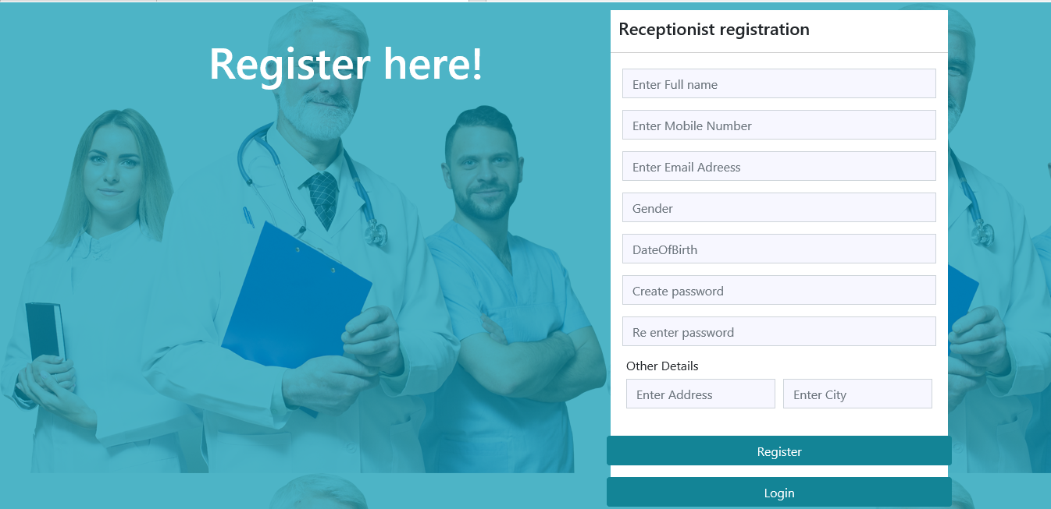

Receptionist Registration module of our Hospital management system the executives framework is intended to oversee fundamental data for the Receptionist data outline, which denotes the start of socioeconomics catch. It incorporates the Receptionist's full name, Receptionist’s Mobile number, Email Address, Gender, contact data, birth date, password, other details, and protection data.

It is utilized to control admin stream. It very well may be utilized to enlist them, get the information of the Receptionist' ailment, see the therapy and check the clinical history and reports

**Receptionist Login Page**

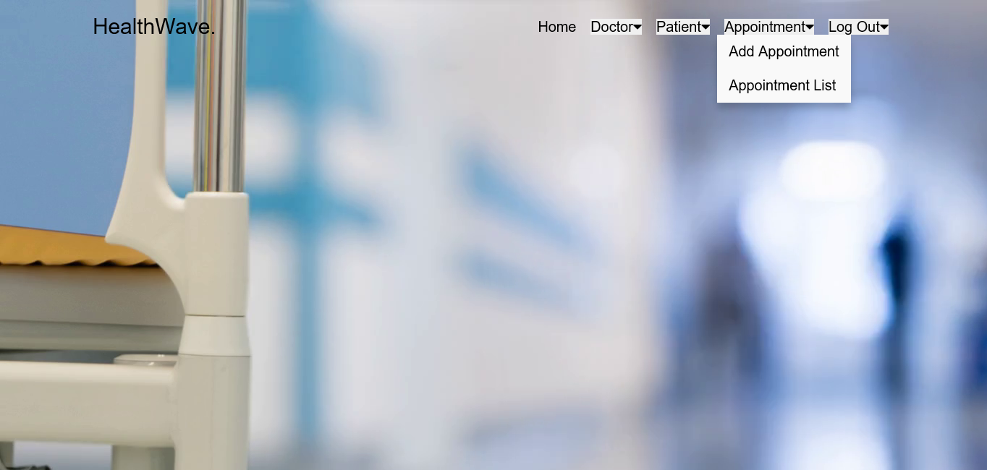

Reception Management module of hospital management system manages front desk reception activities. Status of any patient/doctor can be queried from this module, e.g., timing of consultant, residential address/patient room search.

**Add Appointment Page**

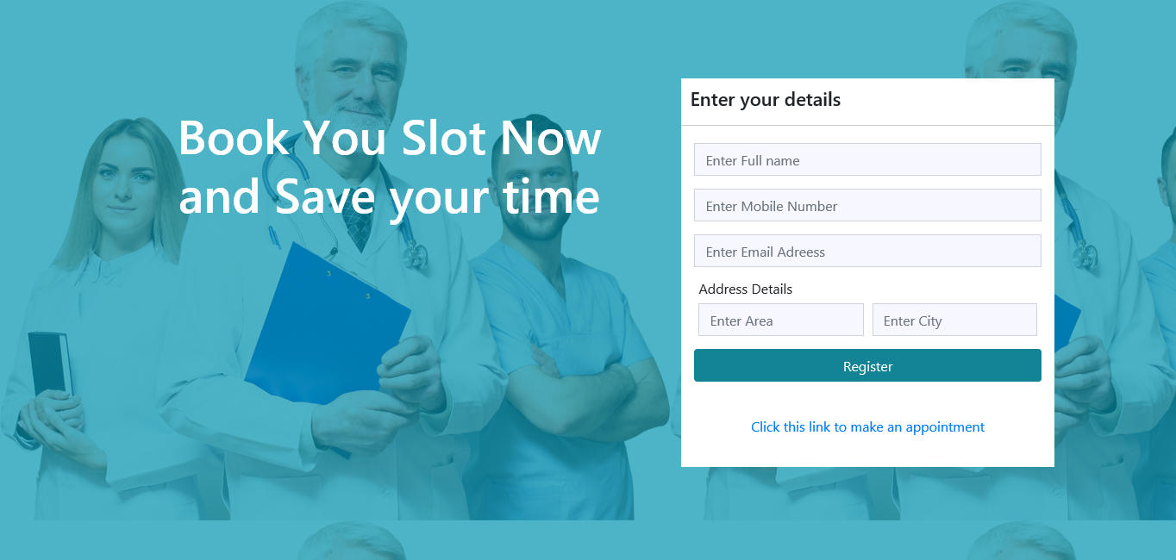

The executives can physically set an arrangement for any client, in the event that they ask so. They

should choose the name, mobile number , email and Address to add an arrangement. This will add arrangement for the specialist and patient both. The arrangement segment additionally have extraordinary significance. This gives the force for all to save time and decrease bother. A patient can just request arrangement however the executives needs to set the arrangement for them. The administration has a few significant obligation here. They need to check if the specialist is free. This will lessen the opportunity of getting various arrangement for each specialist in turn. The specialists can likewise set arrangement for them when they need to. This will be straightforwardly alloted for them and the administration won't have anything to do with this.

**Channel Doctor Page**

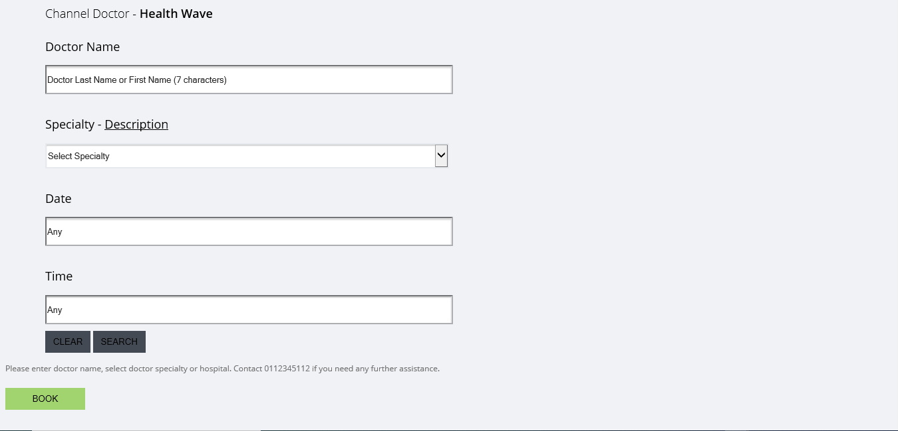

This is another significant obligation regarding the administration. They need to add Doctor account in subtleties. There is different things for a specialist. Under close to home subtleties, specialist data, chamber data, settings there are a few subtleties for the specialist to be added. After fruitful addition of a specialist the executives can allocate them patients and designate them for demands. Every one of those data from each tab should be embedded cautiously as it will appear with the specialists subtleties. Assuming they embed less data, the patients won't be ready to see all data of the specialist. This can prompt a circumstance where the framework may not give the guaranteed advantage to us. So the administration needs to be cautious about this.

**Patient List**

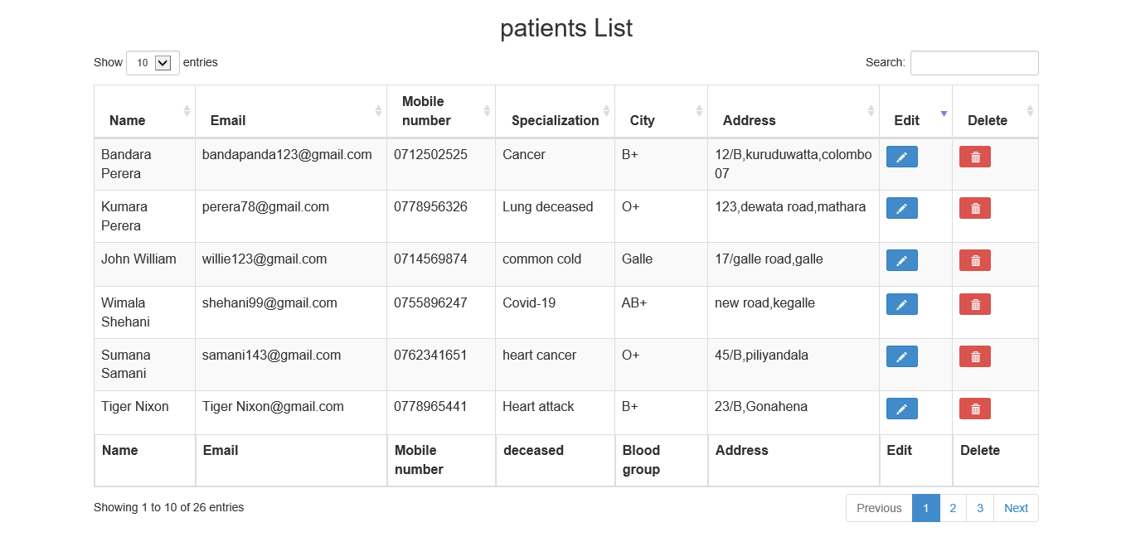

In the wake of signing in patients will see a short portrayal of themselves. There will show up

their name, age, sexual orientation, address, username and secret phrase. Each and every significant

subtleties that is essential will be there for them. This is only the profile page for a patient. They don't numerous moves to make from here however they can check and change their data in this page.

**Appointment List**

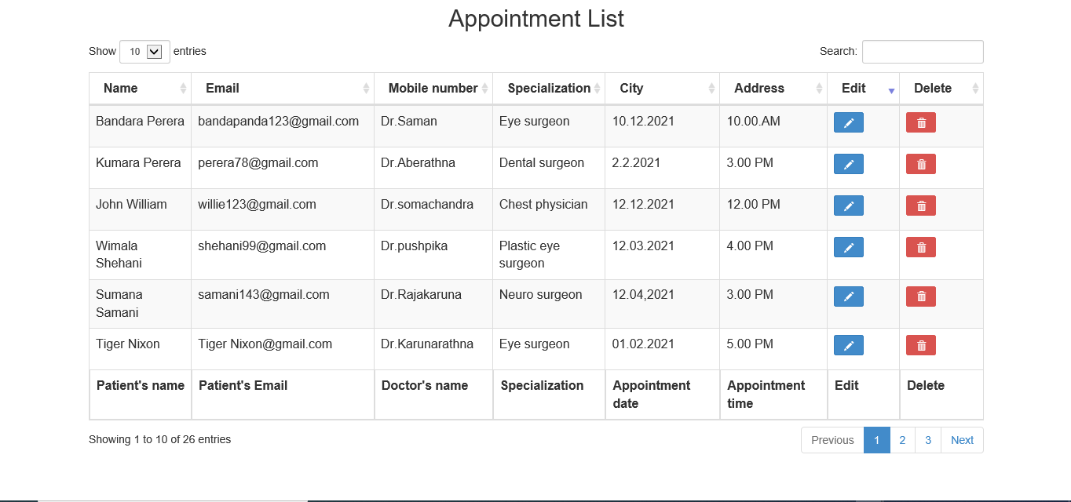

**Doctors List**

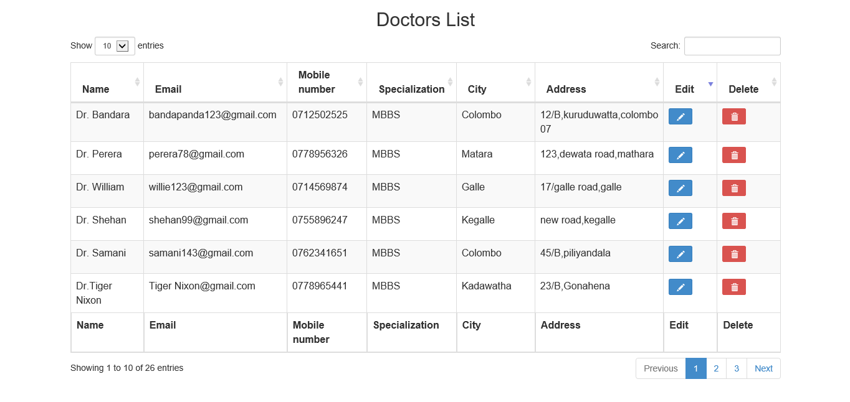

**Conclusion**

Considering every one of the referenced subtleties, we can make the end that the clinic the board framework is the inescapable piece of the lifecycle of the advanced clinical foundation. It computerizes various every day activities and empowers smooth connections of the clients. Building up the medical clinic framework programming is an extraordinary chance to make the particular, effective and quick conveying medical care model. Execution of emergency clinic the board framework project assists with putting away every one of the sorts of records, give coordination and client correspondence, carry out strategies, improve everyday activities, mastermind the inventory network, oversee monetary and HR, and market emergency clinic administrations. This advantageous choice covers the necessities of the patients, staff and medical clinic specialists and improves on their associations. It has become the typical way to deal with deal with the clinic. Numerous centers have effectively encountered its benefits and keep growing new clinic the executives framework project modules.

Need to improve the board in your medical clinic or plan to enhance medical services with new programming item? The clinic framework programming is an incredible answer for any clinical establishment. On the off chance that you have a few thoughts and need the help, you are free to contact Existek. We are a rethinking organization with extraordinary skill in programming improvement and consistently prepared to discover the best methodologies for your organization. On the off chance that you have any inquiries, don't hesitate to get in touch with us by means of the contact structure or start the conversation in the site talk gadget. Existek will be happy to give proficient discussion and discover the answer for you

**References**

* Lecture slides

**Contribution**

|  |  |  |
| --- | --- | --- |
| H.J.K.I. Wijerama | 10707417 |  |
| K.L.D.Amupama | 10707129 |  |
| K.C.Heshan | 10707216 |  |
| U.R.K.Ukwatta | 10713401 |  |
| N.N.D.G.Liyanage | 10707256 |  |